SEO Strategy for [https://www.artgrafix.com](https://www.artgrafix.com/cgi-artgrafix/bo/start.cgi)

*Design Flaws*

The overall design appears out dated, which may impact user trust and engagement.   
  
The website doesn't have high-quality images or appealing creatives. Adding more visuals, especially index page and other landing/product pages, could enhance overall site performance.



The font choices and sizes are too small and difficult to read, especially for body text.   
  


*SEO Checklist*

Proposed Keyword List

foam board

foam boards

adhesive sheets

3m pma adhesive

Shop 3M Adhesives

heavy duty foam board

6ft foam board

giant foam board

1 1/4 foam board

foam board custom size

foam board mounting

white foam board

self adhesive foam board

foam board thick

adhesive for foam board

gator foam boards

foam board lamination

thick foam boards

custom foam board sizes

black foam boards

self adhesive foam boards

heavy duty foam board

foam board thickness sizes

foam board adhesive

custom size foam board

adhesive foam board

sticky foam board

Mounting Boards

black mounting board

gator foam boards

Self-adhesive Boards

Hot Pouch Boards

Cold Pouch Boards

Large Film Pouches

Document Film Pouches

Hot Laminating Films

Cold Laminating Films

Mounting Adhesives

Double-sided Adhesives

Over-Laminate Films

Dry Mount Adhesives

Spray Adhesives

3M PMA Adhesive

self adhesive mounting boards

*On-Page SEO*

There are several areas which need to be improve like technical SEO, content ideas, semantic and backlink ideas etc.

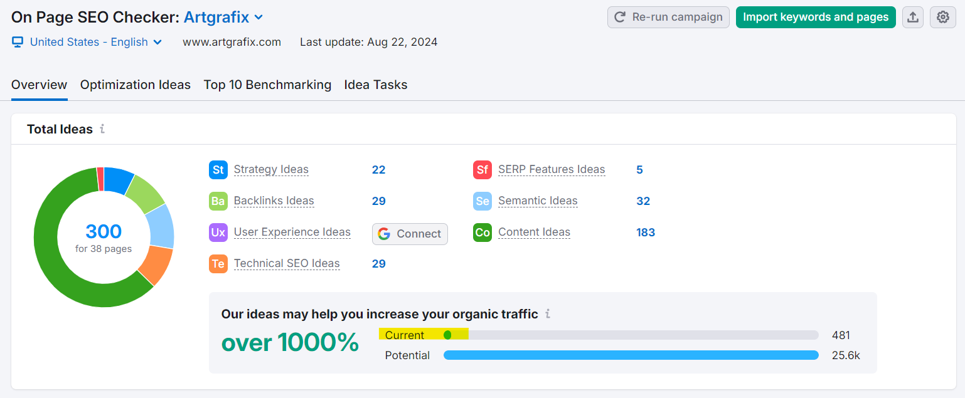

Top pages to optimize

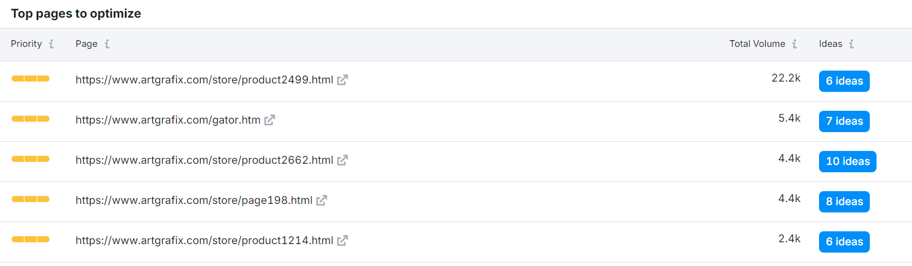

Need to focus on creating more informative content, meta description, heading tag etc.

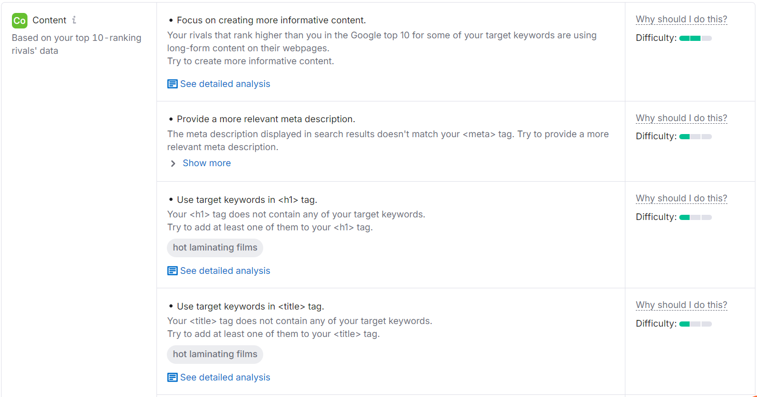

*Technical SEO*: Due to lack of google analytic and search console access we’re unable to provide sufficient data on search performance, user behavior, index coverage and organic traffic insight.

**Content Quality**:

* Create unique, valuable, and engaging content.
* Update content regularly.

**Off-Page SEO**:

* Build quality backlinks from reputable sites.
* Engage on social media.